Header files have an extension ".h" which contain C++ function declarations

Header files contain declaration of **Functions and Variables**, which is imported or used into any C++ program by using the pre-processor #include statement.

Each header file contains information (or declarations) for a particular group of functions.

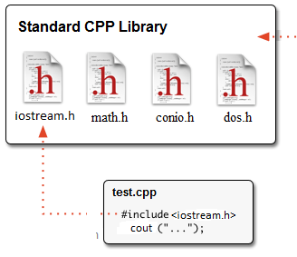

Like **iostream.h** header file contains declarations of standard input and output functions available in C++ which is used for get the input and print the output.

Similarly, the header file **math.h** contains declarations of mathematical functions available in C++.

**Types of Header files**

* **System header files:**It is comes with compiler.
* **User header files:**It is written by programmer.

**Why need of header files**

When we wnt to use any function in our C++ program then first we need to import their definition from C++ library, for importing their declaration and definition we need to include header file in program by using #include. Header file include at the top of any C++ program.

For example if we use clrscr() in C++ program, then we need to include, conio.h header file, because in conio.h header file definition of clrscr() (for clear screen) is written in conio.h header file.

**Syntax**

#include<conio.h>

**Syntax**

#include<iostream>

**int** main()

{

**using** **namespace** std;

cout << "Hello, world!" << endl;

**return** 0;

}

In above program print message on scree hello world! by using cout but we don't define cout here actually already cout has been declared in a header file called **iostream**.

Preprocessor directives are lines included in a program that begin with the character #.

The #include preprocessor directive tells the compiler to include “text” from another file. That file, iostream in this case,

They are invoked by the compiler to process some programs before compilation.